monuments
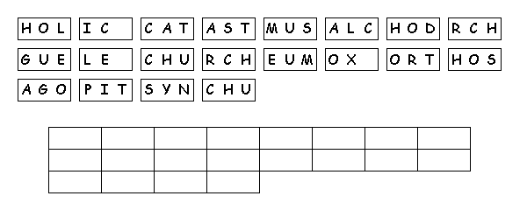
Unscramble the tiles to reveal a message.

