FOOD
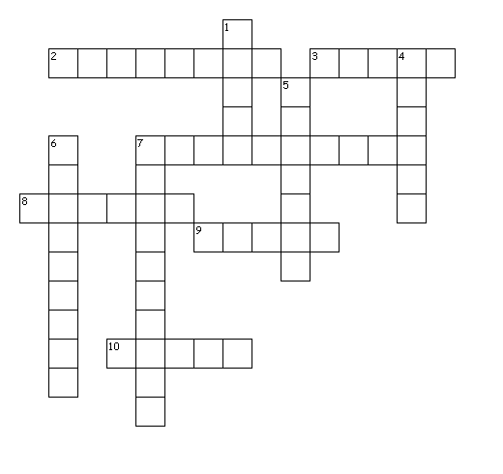
Across
2. It can have different flavours and it’s cold
3. It made by fruit
7. It can have lettuce, ham, cheese...
8. It is prepared from milk fermented
9. When you are thirsty, you drink it
10. It is very health
Down
1. It has got many vegetables
4. It is used for snack
5. It gives you eggs
6. It is sweet and black
7. It is a type of fruit and its color is red

